** Roll Gen™ System Spec Sheet**

**Date: Click here to enter a date. Name: Click here to enter text.**

**Company Name:** Click here to enter text. **Phone #: Click here to enter text.**

TMI DIMS NEEDED_.wmf

*Please reference the drawing above and record your dimensions below*

**Dimensions:**

|  |  |
| --- | --- |
| **A** | **Click here to enter text.** |
| **C** | **Click here to enter text.** |
| **D** | **Click here to enter text.** |
| **E** | **Click here to enter text.** |
| **G1** | **Click here to enter text.** |
| **G2** | **Click here to enter text.** |
| **H** | **Click here to enter text.** |
| **K** | **Click here to enter text.** |
| **TA** | **Click here to enter text.** |

**Belt Width: Click here to enter text.**

**Belt Speed (FPM or MPS): Click here to enter text.**

**Conveyor Run Time/Day: Click here to enter text.**

**Days/Week of Run Time: Click here to enter text.**

**Troughing Angle:**  20°  35°  45**°**

**Idler Diameter**:  5”  6”  7”  Other Click here to enter text.

**Idler Part #:** Click here to enter text. **Idler Manufacturer:** Click here to enter text.

**CEMA Rating:** B  C  D  E  Other Click here to enter text.

**Stringer Width:** Click here to enter text. **See Next Page for More…..**

**What are your intentions for the Martin® Roll Gen™ System?**

LED Lighting  Compressor for Air Tensioner on Belt Cleaners

Activation of Water Supply to Wash Box  Initiation of Spray Bars

Reversing Tracker Mechanism  Firing of Air Cannon

Any Other Application using 24 Volts DC  Other Click here to enter text.

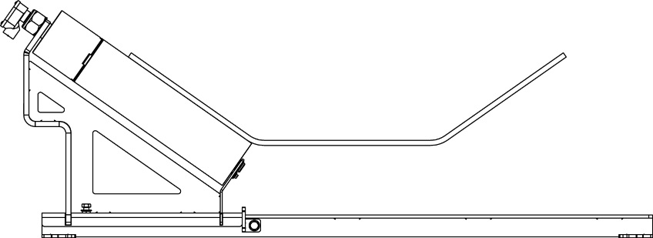

A

**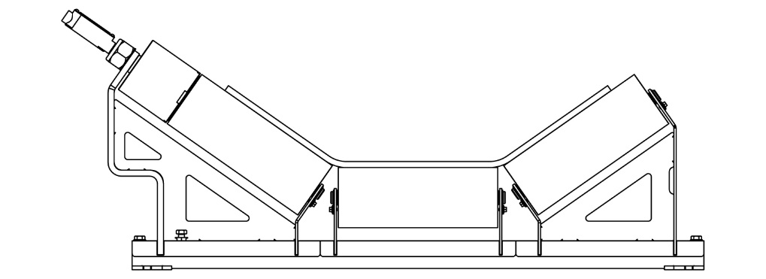**

B

**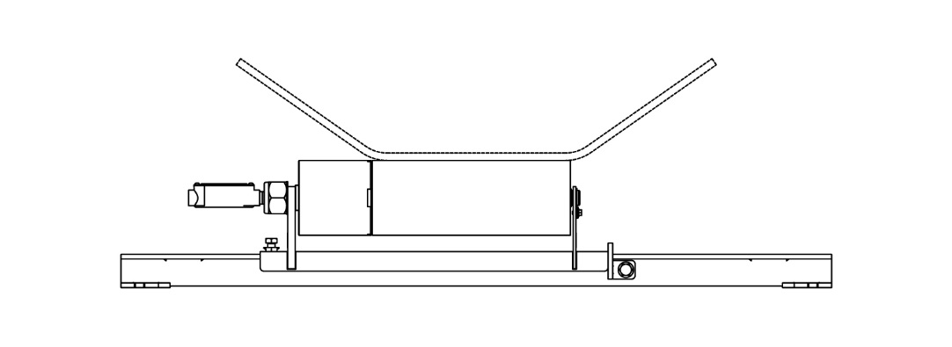**

C

**Which Configuration Above Are You Wanting?**  A  B  C

**Quote #: Click here to enter text.**